**AUTOMATION TESTING USING SELENIUM TOOL FOR STUDENT LOGIN OF THEIR INSTITUTION**

**T. SUMANTH**

**192011452**

**AIM :**

To execute Automation testing using Selenium tool for student login of the institution.

**PROGRAM**

package chennai;

import org.openqa.selenium.By;

import org.openqa.selenium.WebDriver;

import org.openqa.selenium.WebElement;

import org.openqa.selenium.chrome.ChromeDriver;

//import org.testng.Assert;

//import org.testng.annotations.Test;

public class sellinium1 {

public static void main(String[] args) {

System.out.println("hai"); System.setProperty("webdriver.chrome.driver","C:\\manik\\CSA37 Lab details\\Sellinium and junit\\selenium jar\\chromedriver_win32\\chromedriver.exe");

WebDriver driver = new ChromeDriver();

//driver.get("https://www.google.com/");

driver.manage().window().maximize();

driver.get("https://arms.sse.saveetha.com");

WebElement username=driver.findElement(By.id("txtusername"));

System.out.println(username);

WebElement password=driver.findElement(By.id("txtpassword"));

System.out.println(password);

WebElement login=driver.findElement(By.name("btnlogin"));

System.out.println(login);

username.sendKeys("192011079");

password.sendKeys("VARDHAN@123");

login.click();

}

}

**OUTPUT**

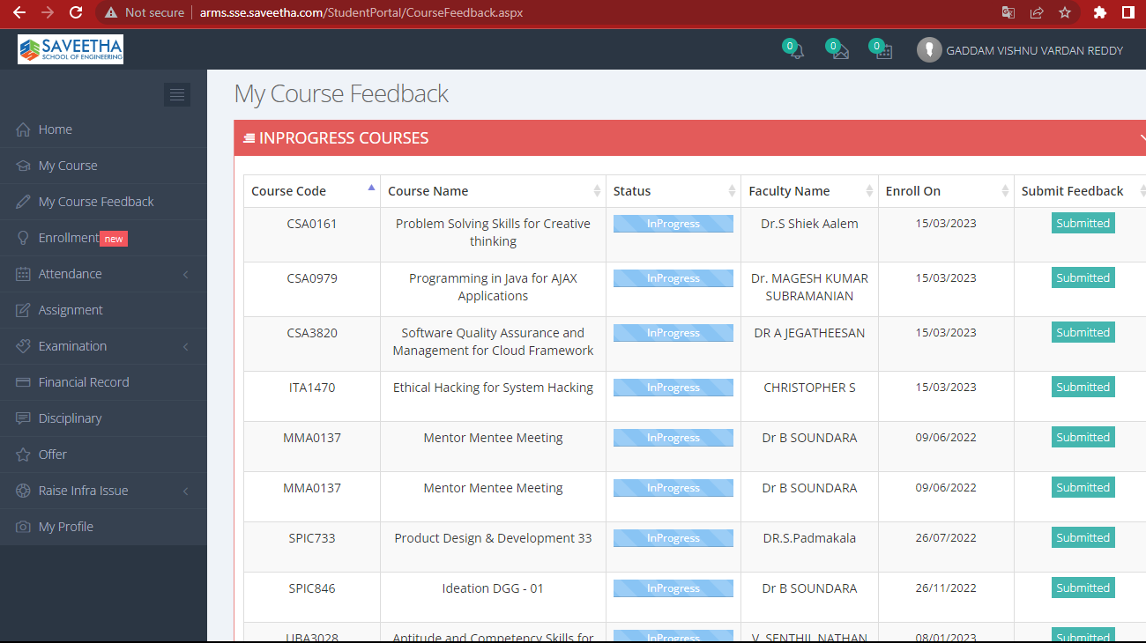

**RESULT**

Hence Automation testing for student login of their institution is Executed successfully.